Evaluation of Titration Intervention
1. Background:
Titration intervention is an optional alternative treatment for patients with neuropathic pain, in which a reduced treatment duration (e.g., 20, 15, 10, or 5 minutes per session) is recommended instead of the standardized dose of 30 minutes twice daily.
There are three types of treatment:
- Non-titration: Patients who use the device for 30 minutes per therapy session starting from the initial treatment point (time/day = 0).
- Proactive titration: Patients who use the device for less than 30 minutes per session from the initial treatment point (time/day = 0).
- Reactive titration: Patients who reduce their treatment duration to less than 30 minutes per session during the course of treatment. The suggested duration varies across patients (e.g., 20, 15, or 10 minutes).
2. Data Structure: Long Format
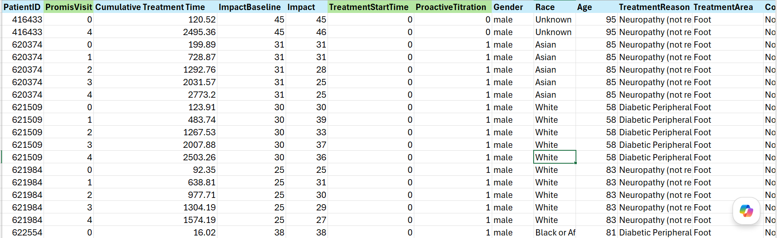
- Intervention: Proactive Titration (Binary =1)
- IV: Titration Intervention (Cumulative Treatment Time)
- DV: Impact Score (ranging from 4 to 50)
- Covariates: Demographics, Medical history (disease, diabetes, surgery, foot ulcer, medication, treatment reason, treatment area, contraindication)

3. Sample Descriptives
Table 1-1. Descriptives of Sample Demographics
Table 1-2. Descriptives of Treatment Reasons and Areas

Table 1-3. Descriptives of Medical Conditions

Table 1-4. Descriptives of Pain Intensity Baseline

3. Research Questions
- What is the effect of proactive intervention compared to non-titration?
- What is the effect of reactive intervention before and after implementation?
4. Analytical Methods: Difference-in-Difference
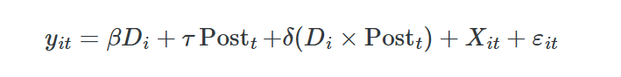
Note. D = Intervention, Post = Time Point (Wave), X= Covariates
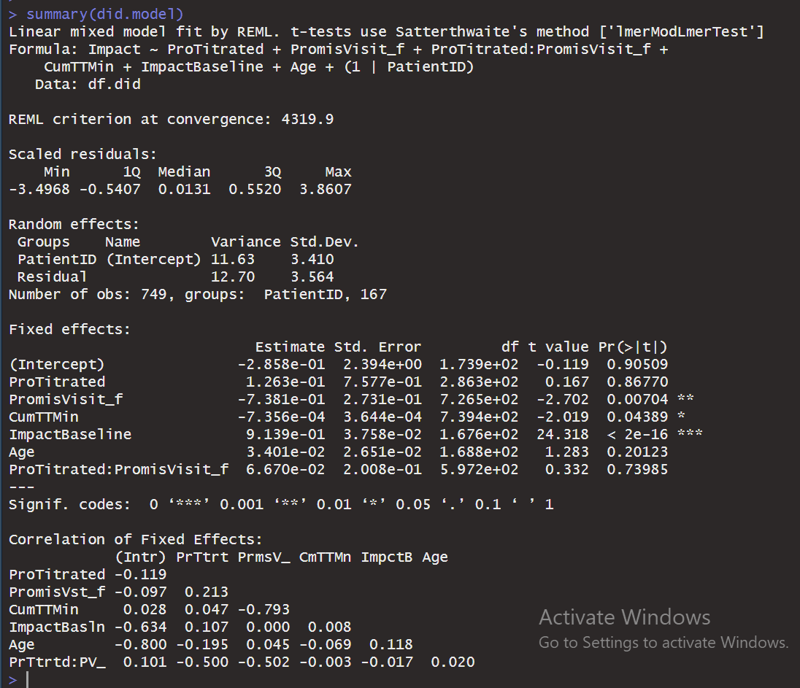
After IPSW, both age and baseline score remained imbalanced (see Love Plot below). To address this, both variables were included as covariates in the model for additional adjustment.

5. Results
Q1: What is the Effect of Proactive Intervention compared to non-titration?

- Inverse Propensity Score Weighting (IPSW) for Proactive vs. Non-Titration
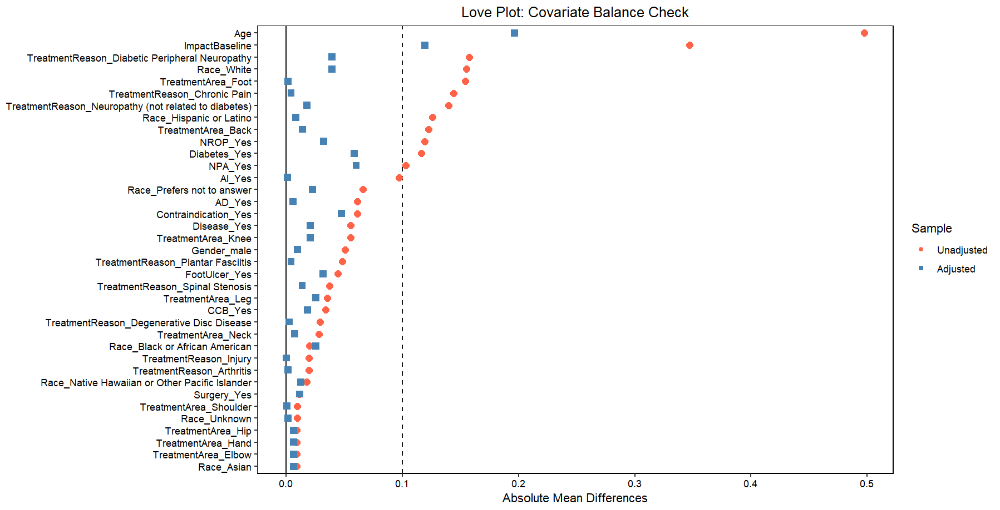
- Parallel Graph of DiD Outcomes for Proactive Titration vs. Non-Titration Over Time

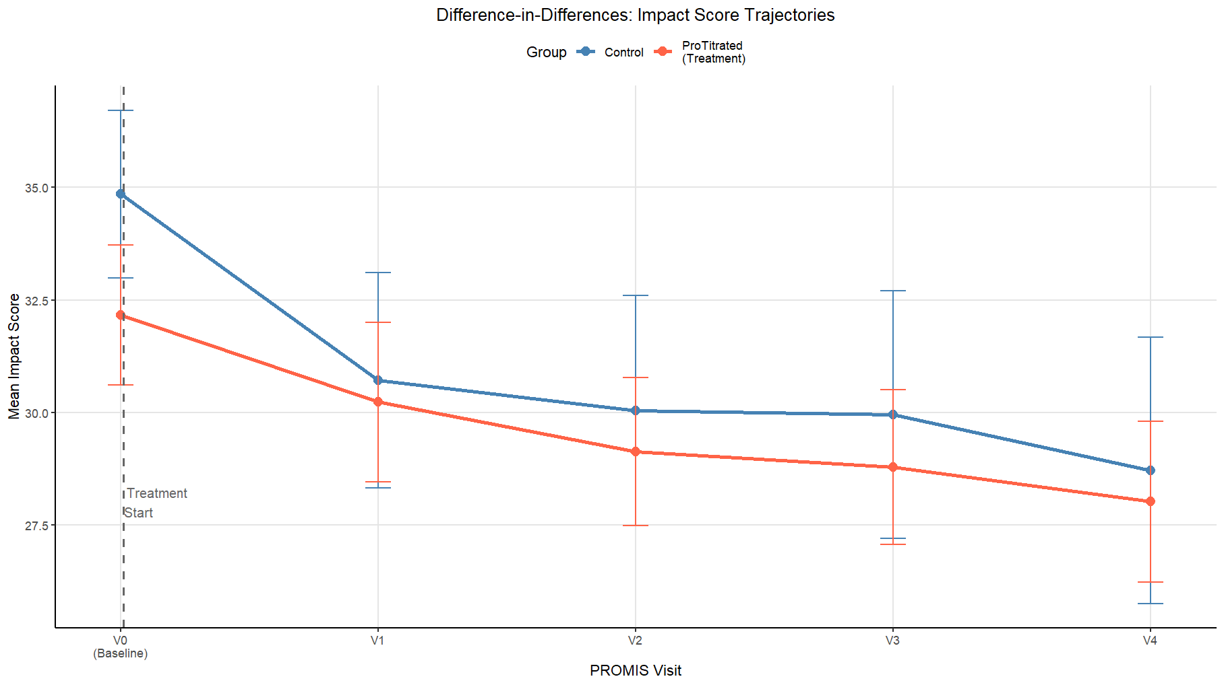
- DiD Outcome Table for Proactive Titration vs. Non-Titration Over Time
PromisVisit (Time Point) | DiD Estimate | Lower CI | Upper CI | p | Cohens d
1 (15 day) | 1.54 | -0.15 | 0.07 | 0.07 | 0.44
2 (30 day) | 1.17 | -0.51 | 0.17 | 0.17 | 0.34
3 (45 day) | 0.272 | -1.43 | 0.75 | 0.75 | 0.08
4 (60day) | 0.798 | -0.93 | 0.37 | 0.37 | 0.24
Note. The reference group is non-titration. Positive points in DiD estimate indicate higher pain levels. Negative estimates indicate lower pain levels relative to the reference group.
Conclusion: Proactive titration did not demonstrate meaningful effectiveness compared to non-titration. Although the difference between groups was smallest around Day 45, a small-to-moderate difference relative to the non-titration group remained consistent overall.
Q2. What is the effect of reactive intervention before and after implementation?
Since the sample size of reactive patients was small (n = 20), I examined individual pain trajectories to assess changes in pain before and after reactive titration. Of the 20 patients, 6 (30%; IDs: 628361, 648378, 649226, 6611369, 678413, 686792) showed a decrease in pain following the reactive intervention. However, it remains unclear whether the observed pain reduction was attributable to the treatment or to other factors.